Introduction of the
Queen’s Scout Award
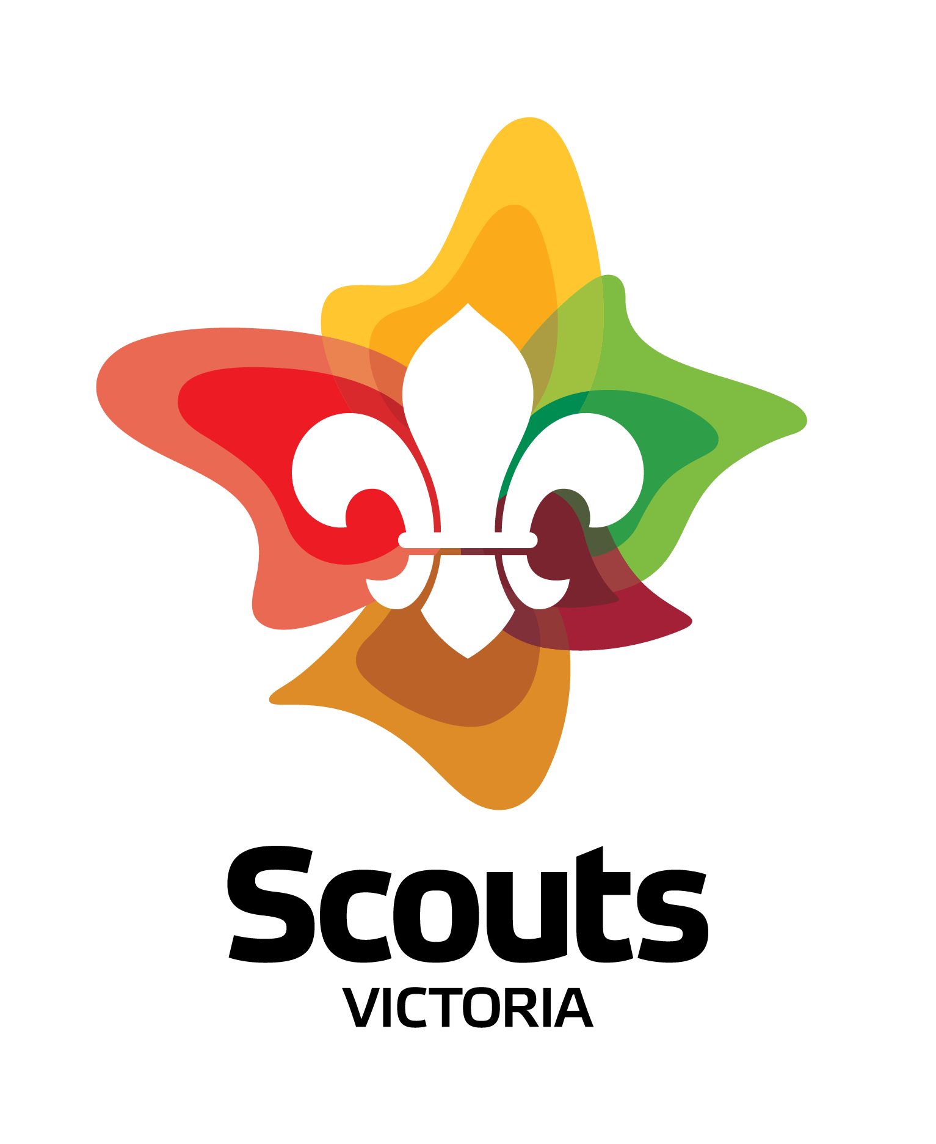
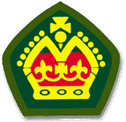

The Queen’s Scout Award is something which is widely recognized in the Community, yet probably not many people know what it really means.
The words “Queen’s Scout” conjure up an image to some of a clean cut young person helping a little old lady across the road, and yet, like so many things in life the true significance of the Queen’s Scout Award goes much deeper than the general public’s perception. It is a Tribute to the high standards of the Award, and the number of young people who achieve it, that the Award is so widely recognized in the first place.
Technically, the Queen’s Scout Award is the Highest award available to the Venturer Scout Section of Scouts Australia; young people aged between 15 and 17.
It is not the Scouts highest award, but it is the most often presented.
A Venturer Scout will take close to 300 hours and often more, through personal choice to achieve the award, they achieve it at a time of their life when they are going through their teenage years and when they are under pressure from school and VCE and when they are resolving the larger issues of who they are and which direction they want to take in life.
The Queen’s Scout Award is not just about passing badges either. A potential Queen’s Scout is evaluated by the Scouts Victoria right up to State Level on whether they have and will continue their Scout Promise of service to their God, their Country and Their community.
The Queen’s Scout Award produces a certain type of person, someone who is willing to serve their community, someone who is willing to have a go at expanding their skills and meet challenges. Those skills are judged as valuable in today’s community and are often recognized by potential employers.
Although these skills go across the board for Queen’s Scouts no two ever follow the same path to achieve the award. Flexibility is built in to recognize individuals and the paths that they may wish to take.
The Queen Scout’s Award is made up of four components that are compulsory they are: Community Involvement; Outdoor Activity; Personal Growth and Leadership.
Above all the Queen’s Scout Award is all about endless opportunity, Fantastic fun and learning by doing……. All the things that the Scouting is about too.
***********************************************************************

