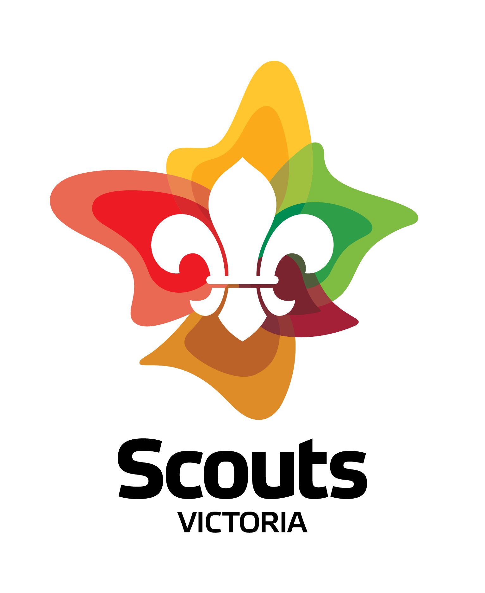
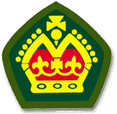
History of the Queen’s Scout Badge

A Queen's Scout is a Venturer who has attained the peak youth award achievable in this section. This award is presented in the Commonwealth realms, including the United Kingdom, Canada, Australia, and New Zealand, where Scouts operate under the patronage of Queen Elizabeth II. Whether the award recipient is a Queen's or King's Scout depends on who is the current Monarch of the Commonwealth.
In 1909, just two years after Baden-Powell ran the first scout camp on Brownsea Island he was spending the weekend with the King of England, Edward VII. Over the course of the weekend, Lieutenant-General Robert Baden-Powell, as he was then, was informed that he was to be knighted for “services to the country, in particular for the starting of Scouts”.
This led to further conversation with the King over the weekend where B-P suggested that the highest qualified scouts might be known as King’s Scouts. King Edward agreed and suggested that the recipients of this award should be presented to him. King Edward died before this could happen, but his successor, George V, adopted the idea and the first King’s Scouts were presented in 1910 with a badge with the royal crown signifying the award as a "King's Scout".
After the establishment of the Senior Scout section in 1946, only Senior Scouts (or Boy Scouts over 15) could become King's Scouts.
The Badge was first awarded in Victoria in 1911 as the King’s Scout badge and after the succession of Queen Elizabeth II in 1952, the award was renamed the "Queen's Scout" Award.
Initially the award required demonstrated proficiency in standardised scoutcraft and skills useful for service to others and the nation. The current requirements are different in each country and now focus on personal development and typically involve achieving challenges from several areas such as community involvement, outdoor activities, personal growth and leadership development.
To date there has been over 14,000 recipients of this prestigious award in Victoria and the records show that less than 4% of Venturers gain the Queen’s Scout Award.
For <today’s recipient>, this is a culmination of <his/her> endeavours over a number years and <he/she> should be congratulated on this great achievement.

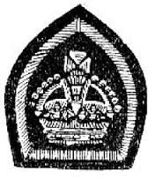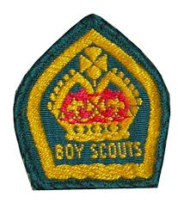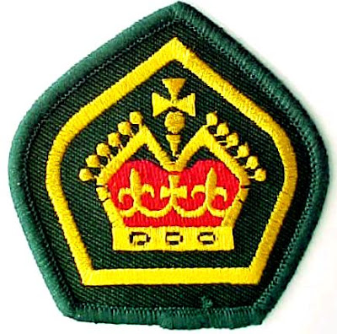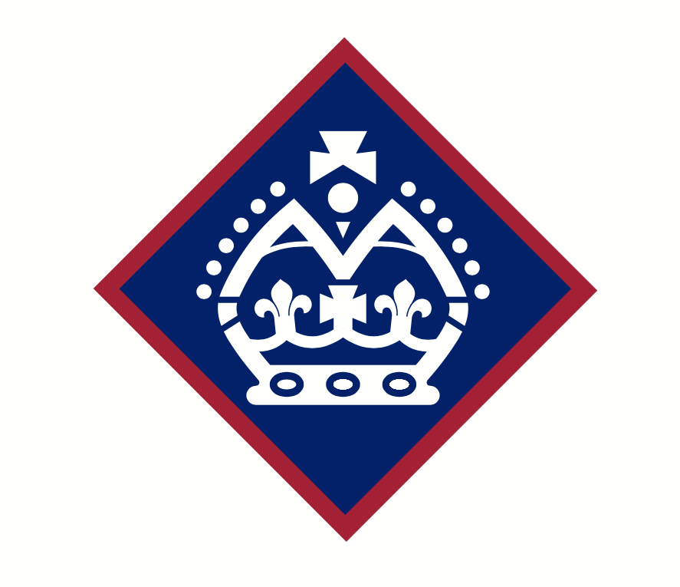

Symbolism of the Queen’s Scout Badge
The crown represents the allegience to the Queen through the Parliament and Laws of Australia and the Governor of Victoria as the Queen’s representitive.
The “V” shape on the badge indicates that the award is presented to a Venturer.
The cross at the top of the badge represents God and the Queen’s scout spiritual awareness.
The ball (or orb) signifies we are all members of the one worldwide Scouting movement.
The two symettrical Fleur de Lys inside the crown represent the Scout Law while the cross represents the Scout Promise.
The three circles at the base of the crown signify the three sections of the Scouting Movement (Cubs, Scouts and Venturers) that the recipient has been involved in prior to this award. (before Joey Scouts were created).
The six circles on each side of the crown signify the activity areas which the recepient undertakes to complete the elements of the Venturer Award Scheme.
The total symetrical design signifies the “all round” training that the Queen’s Scout has achieved.

